Current and Correct setup for this iView:
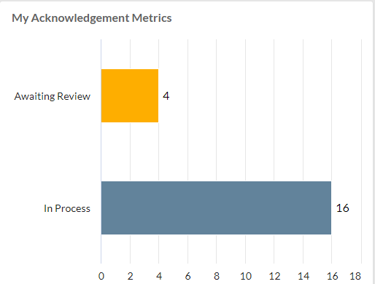

Click into the chart setup and select ‘Modify’.
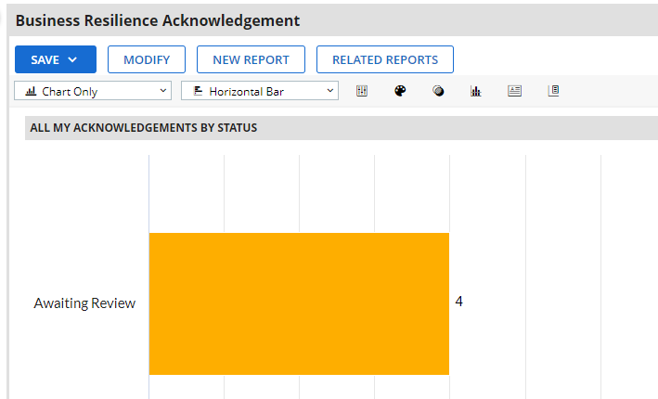
NO changes are made within this screen.
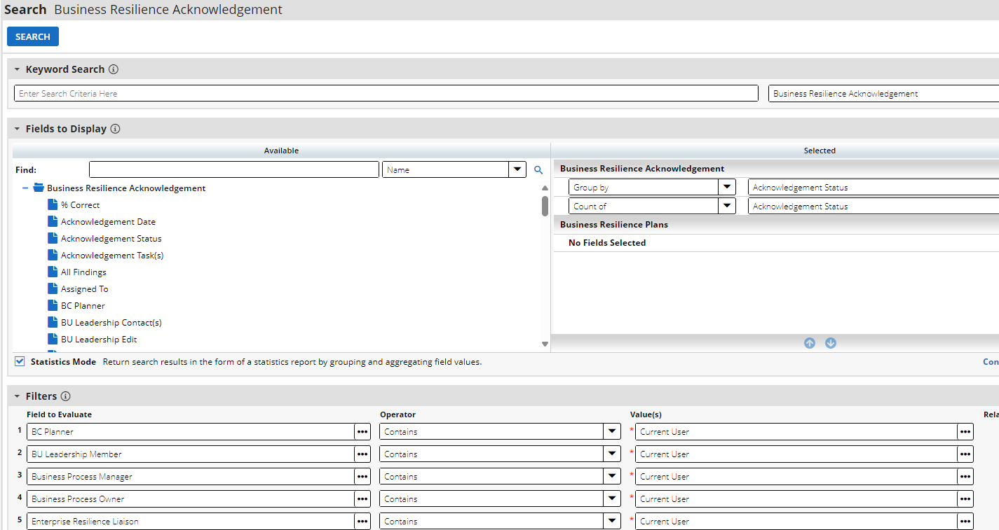
Select Search and now the setup for the chart has the Titles showing even though they were not setup to be this way. We have to make the change to remove the Titles every time we go into a report and chart to remove this.
