Archer SaaS Migration

Questionnaire - On-Premises

Introduction
The answers to questions below help determine viability and level of effort for migrating an on-premises instance into the Archer SaaS or Archer SaaS FedRAMP offerings.

Instance Configuration Information
Providing a configuration reports of your Archer environments is necessary for us to help understand your sizing requirements for Archer SaaS or Archer SaaS FedRAMP. Minimally, the information for your production environment is necessary. Information for non-prod environments helps provide further detail.

The specific instructions for generating and saving the reports are in the Appendices.

Number | Artifact | Source
ICI-04-Q | Instance Reports (for each instance) | Instance and Installation Reports
ICI-05-Q | Installation Report | Instance and Installation Reports

Provide Instance and Installation Reports.

Instance Review

User Management and Access

Number | Question | Source
UMT-04-Q | If using Single Sign-On please specify type:  - Windows Authentication  - Header Parameter  - Federated  - SAML | Reported by Client  ACP | Instance | Single-Sign-on
UMT-04-R
UMT-05-Q | If not using Federated or SAML, is your organization able to leverage an Identity Provider using SAMLv2? | Reported by Client
UMT-05-R
UMT-06-Q | What federated Identity Provider (IdP) do you leverage? | Reported by Client
UMT-06-R
UMT-07-Q | Are you using the LDAP Synchronization Service?  If so, are you synchronizing Groups as well? | Reported by Client
UMT-07-R

Optional Environment Configuration

Number | Question | Source
APC-03-Q | Are you using field level encryption? (Enabled in Archer Control Panel) | Reported by Client
APC-03-R
APC-04-Q | If using field level encryption, how many fields across how many applications (including questionnaires) are being encrypted? | Reported by Client
APC-04-R

Integrations

Number | Question | Source
ING-01-Q | In general, how many and what types of data feeds are in use? | Reported by Client  Instance Report | Data Feed Configurations
ING-01-R
ING-02-Q | Do you have any JavaScript Transporter data feeds that were not provided by Archer? | Reported by Client  Instance Report
ING-02-R
ING-03-Q | Are any of your Archer-to-Archer (Archer Web Services) transport data feeds set up as Transport Only (as opposed to Standard) | Reported by Client |  Data feed Configuration – General tab
ING-03-R
ING-11-Q | Have you performed any modifications to the Archer database including additions, deletions, or modifications of any table, foreign key, index, partition, view, stored procedure, function, or trigger? | Reported by Client
ING-11-R
ING-12-Q | Do you have any systems that interact directly with the Archer database?  If so, please provide insights. | Reported by Client
ING-12-R
ING-13-Q | Are you currently using any of the below features?  - Data Publication Service  - Data Gateway | Reported by Client
ING-13-R
ING-14-Q | Are you currently using any of the below data feed transport types?  - Database Query Transport (SQL, et al)  - Mail monitor Transport | Reported by Client | Instance Report
ING-14-R
ING-15-Q | Is there any custom code, services, or middleware deployed to any server running the Archer system for use with Archer?  For the purposes of this question, “custom code” includes anything that is not delivered by the Archer product installation. | Reported by Client
ING-15-R
ING-18-Q | Are you using the Engage platform?  Engage for Business Users and/or Engage for Vendor Portal | Reported by Client
ING-18-R

Appendices

Instance and Installation Reports in the ACP
In addition to answering these questions, please pull a current Instance Report and Installation Report from the Archer Control Panel. These can provide further insight and provide answers to some of the questions below:
- Instance Report
- Installation Report

Note that these may take some time to be picked up by the Job Engine and run. They gather a lot of data and should open IE when complete. Go to:

- ACP | Plugins (top menu) | Configuration Report
- Select the Instance you want and select Start Report Job.
- Repeat this for each Instance.
- Likewise, select the Installation option to generate that report.
- When the report has completed, Save As “HTML”.

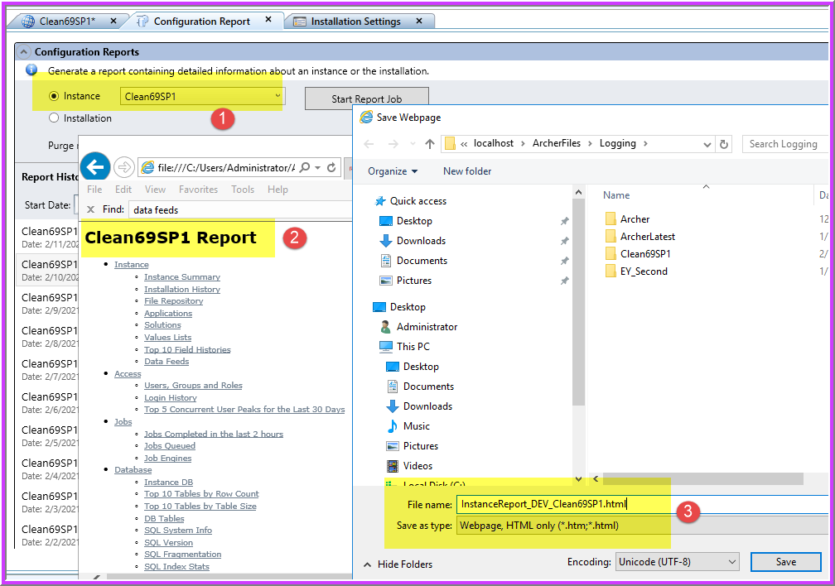

- Then right-click on the report and Export as XML.

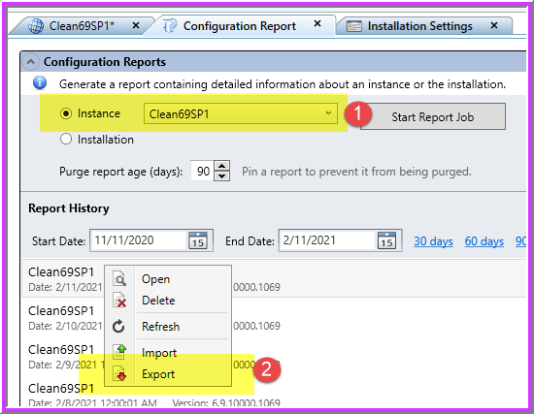

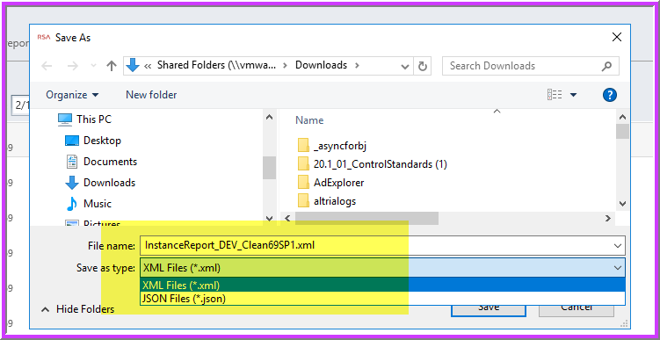

- Please be sure to name them something recognizable. e.g.:

Installation_PROD_Clean69SP1.html
InstallReport_PROD_Clean69SP1.xml
InstanceReport_DEV_TestInstance.html

For additional information on generating these reports reference the KB at https://www.archerirm.community/t5/knowledge-base/how-to-generate-rsa-archer-configuration-reports/ta-p/5360

